ព្រះរាជាណាចក្រកម្ពុជា

ជាតិ​ សាសនា ព្រះមហាក្សត្រ

Institute of technology of Cambodia

Department of Information and communication Engineering



TP02: Set Theory

Cours: Theory of Computer Science

Lecturer: KONG PHUTPHALLA

Student: VEN THON

ID: e20191250

Group: I3-GIC-C

Year: 2022-2023

1. if we have a set N={6,4,8,10} and P={10,4,6,8,8} . Is N=P?

* is N=P.

1. Differences between real and rational number:

. Real number is a value of a continuous quantity that can represent a distance along a line, Real number include both rational and irrational number (12.3,-12, $π$,..)

. Rational number is a type of real numbers, which is in the form of p/q where q is not equal to zero (1.5, 2.6, -3.8, 18,…….)

1. If we have a set L={d,b,p,p} and Q={p,d,d,c,p} Is L subset Q?

* No, L is not subset Q.

1. What is cardinality of A={X $∈N+\left|x<168\right\}?$

* Cardinality of A is |A|=167.

1. What is cardinality of B={e,{e,e},{e,a,e},c,{c,e,c,e}}? Power?

* The cardinality of B=5
* P(A)=2^B=2^5=32, So that power is 32.

1. If we have a set A={1,3,5} and B={9,6,3,1} what is A union B? A intersection B?

A difference B?

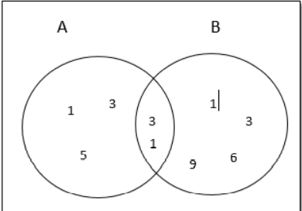

A union B= A U B={1,3,5,6,9}

A intersection B= A $∩$ B={1,3)

A difference B= {5}

1. Find (A $∩B)∪(B∩C)?$

|  |  |  |  |  |  |
| --- | --- | --- | --- | --- | --- |
| A | B | C | A $∩B$ | B $∩C$ | $$(A∪B)∪(A∩B)$$ |
| 0 | 0 | 0 | 0 | 0 | 0 |
| 0 | 0 | 1 | 0 | 0 | 0 |
| 0 | 1 | 0 | 0 | 0 | 0 |
| 0 | 1 | 1 | 0 | 1 | 1 |
| 1 | 0 | 0 | 0 | 0 | 0 |
| 1 | 0 | 1 | 0 | 0 | 0 |
| 1 | 1 | 0 | 1 | 0 | 1 |
| 1 | 1 | 1 | 1 | 1 | 1 |